

**RÉSIDENCES MAME DIARRA**

***Chez vous à* BAYAKH**

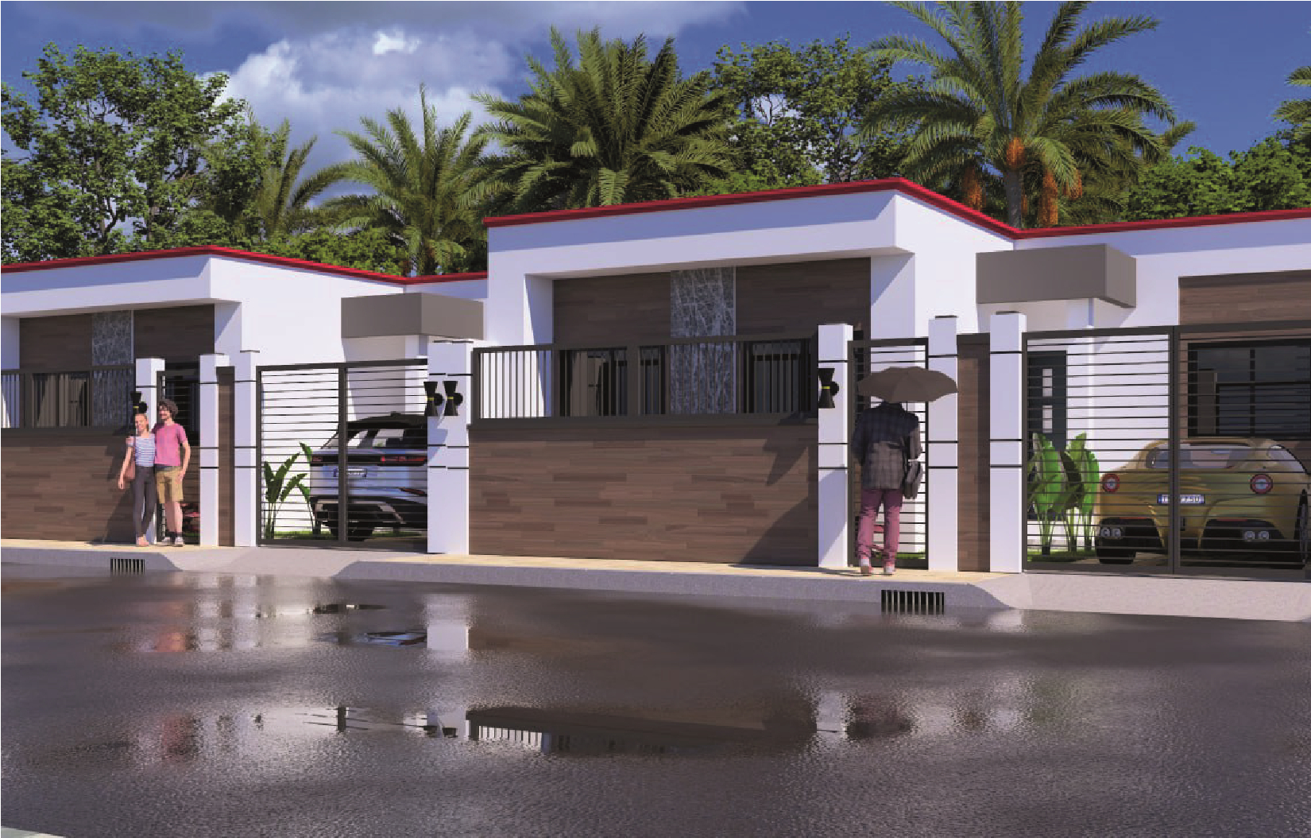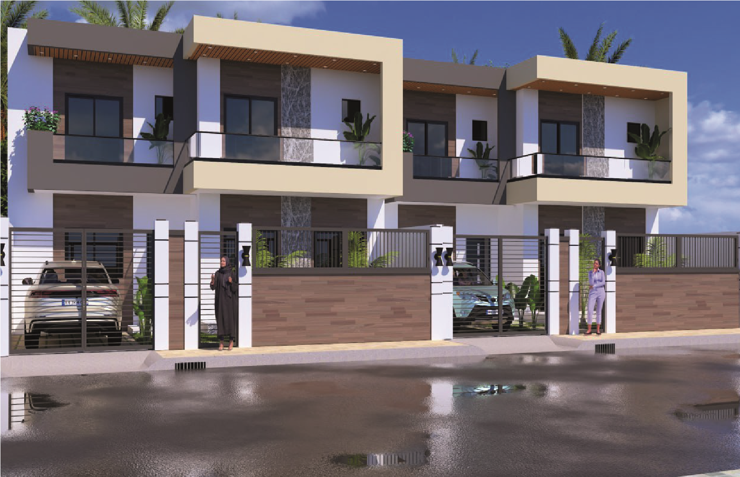

|  |  |  |  |  |  |  |  |  |  |  |  |  |  |  |
| --- | --- | --- | --- | --- | --- | --- | --- | --- | --- | --- | --- | --- | --- | --- |
|  | |  |  |  |  |  |  |  |  |  |  |  |  |  | | --- | --- | --- | --- | --- | --- | --- | --- | --- | --- | --- | --- | --- | | |  | | --- | | 3 PIECES : 2 CHAMBRES - SALON | | SURFACE m² | | Salon 17.50 | | Espace familial 08.90 | | Chambre Parents 15.80 | | Chambre 02 11.55 | | Cuisine 7.40 | | Salle de bain 2.60 | | Toilette 2.60 | | Dégagement 5.75 | | Porche 1.60 | | **Surface Habitable 73.70** | | |
| |  | | --- | | Prix hors frais notaire : 25 500 000 FCFA | |

VILLA SALY - TYPE F3 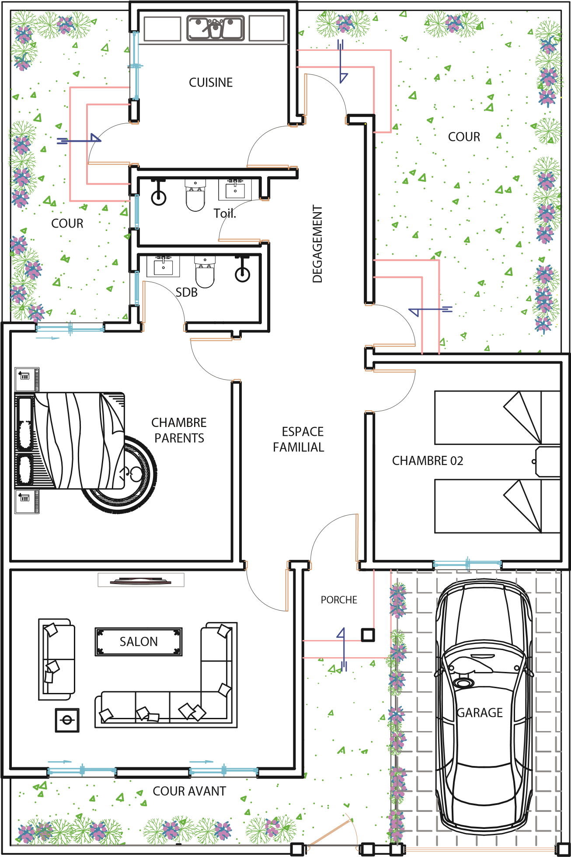

|  |  |  |  |  |  |  |  |  |  |  |  |  |  |  |  |  |  |  |  |  |  |  |  |  |  |  |  |  |  |  |  |  |  |  |  |  |  |
| --- | --- | --- | --- | --- | --- | --- | --- | --- | --- | --- | --- | --- | --- | --- | --- | --- | --- | --- | --- | --- | --- | --- | --- | --- | --- | --- | --- | --- | --- | --- | --- | --- | --- | --- | --- | --- | --- |
|  | |  |  |  |  | | --- | --- | --- | --- | |  | | | | |  | 3 PIECES : 2 CHAMBRES - SALON | |  | | SURFACE | m² | | Salon | 17.50 | |  | Espace familial | 08.90 |  | | Chambre Parents | 15.80 | | Chambre 02 | 11.55 | | Cuisine | 7.40 | | Salle de bain | 2.60 | | Toilette | 2.60 | | Dégagement | 5.75 | | Porche | 1.60 | | Escaliers | 7.55 | | **Surface Habitable** | **81.25** | |  | | |
| |  | | --- | | Prix hors frais notaire : 26 500 000 FCFA | |

VILLA SALY - TYPE F3 AMELIOREE 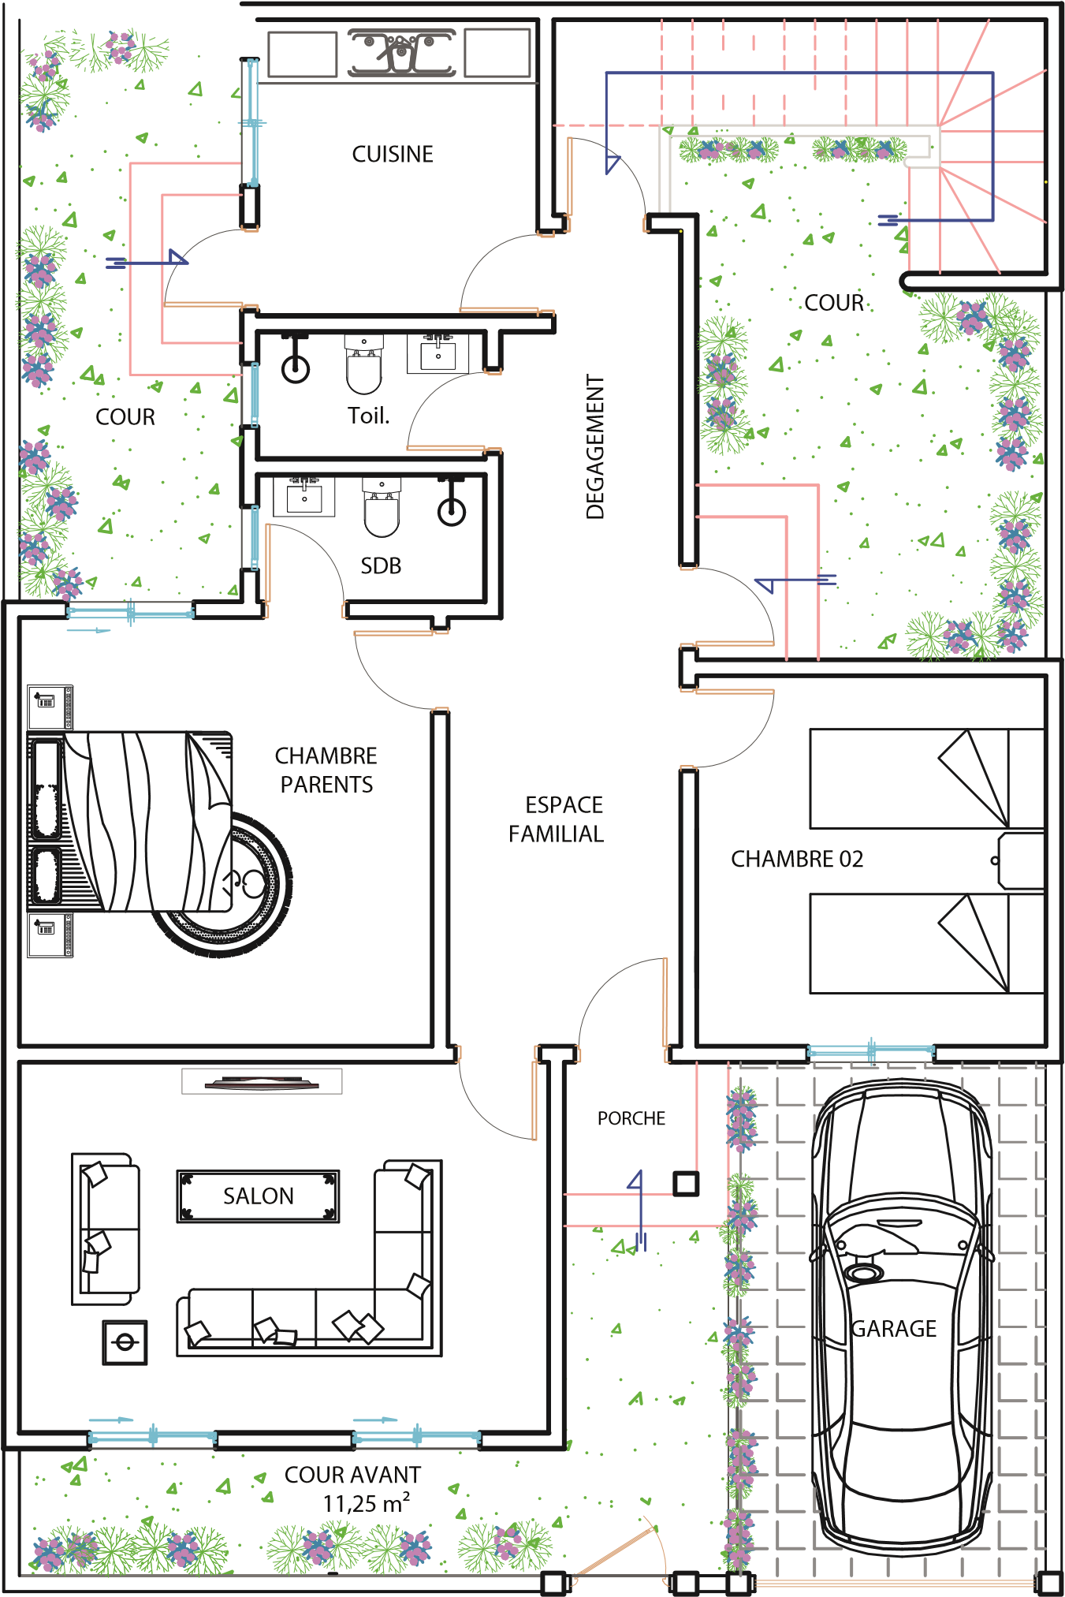

|  |  |  |  |  |  |  |  |  |  |  |  |  |  |  |  |  |  |  |  |  |  |  |  |  |  |  |  |  |  |  |  |  |  |  |  |  |  |
| --- | --- | --- | --- | --- | --- | --- | --- | --- | --- | --- | --- | --- | --- | --- | --- | --- | --- | --- | --- | --- | --- | --- | --- | --- | --- | --- | --- | --- | --- | --- | --- | --- | --- | --- | --- | --- | --- |
|  | |  |  |  |  | | --- | --- | --- | --- | |  | | | | |  | 4 PIECES : 3 CHAMBRES - SALON | |  | | SURFACE m² | | | Salon | 17.50 | |  | Espace familial | 08.90 |  | | Chambre Parents | 15.80 | | Chambre 02 | 11.55 | | Chambre 03 | 11.55 | | Cuisine | 7.40 | | Salle de bain | 2.60 | | Toilette | 2.60 | | Dégagement | 5.75 | | Porche | 1.60 | | **Surface Habitable** | **85.25** | |  | | |

|  |
| --- |
| Prix hors frais notaire : 29 500 000 FCFA |

VILLA AICHA - TYPE F4 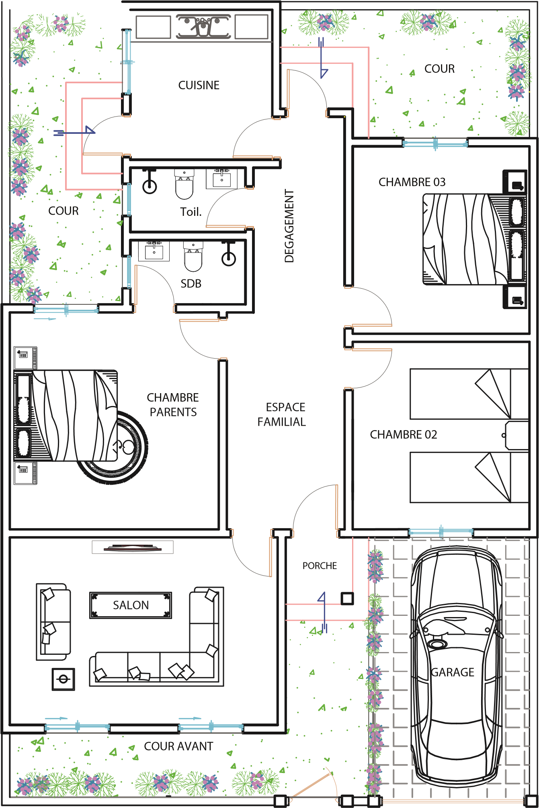

|  |  |  |  |  |  |  |  |  |  |  |  |  |  |  |  |  |  |  |  |  |  |  |  |  |  |  |  |  |  |  |  |  |  |  |  |  |  |  |  |  |  |  |  |  |  |  |  |  |  |  |  |  |  |  |  |
| --- | --- | --- | --- | --- | --- | --- | --- | --- | --- | --- | --- | --- | --- | --- | --- | --- | --- | --- | --- | --- | --- | --- | --- | --- | --- | --- | --- | --- | --- | --- | --- | --- | --- | --- | --- | --- | --- | --- | --- | --- | --- | --- | --- | --- | --- | --- | --- | --- | --- | --- | --- | --- | --- | --- | --- |
|  | |  |  |  |  |  | | --- | --- | --- | --- | --- | |  | | | | | |  | 4 PIECES : 3 CHAMBRES - SALON | | |  | | SURFACE m² | | | | 1 | Salon | 17.50 | |  | 2 | Espace familial | 08.90 |  | | 3 | Chambre Parents | 15.80 | | 4 | Chambre 02 | 11.55 | | 5 | Chambre 03 | 11.55 | | 6 | Cuisine | 7.40 | | 7 | Salle de bain | 2.60 | | 8 | Toilette | 2.60 | | 9 | Dégagement | 5.75 | | 10 | Porche | 1.60 | | 11 | Escaliers | 7.55 | |  | **Surface Habitable** | **92.80** | |  | | | |

|  |
| --- |
| Prix hors frais notaire : 30 500 000 FCFA |

VILLA AICHA - TYPE F4 AMELIOREE 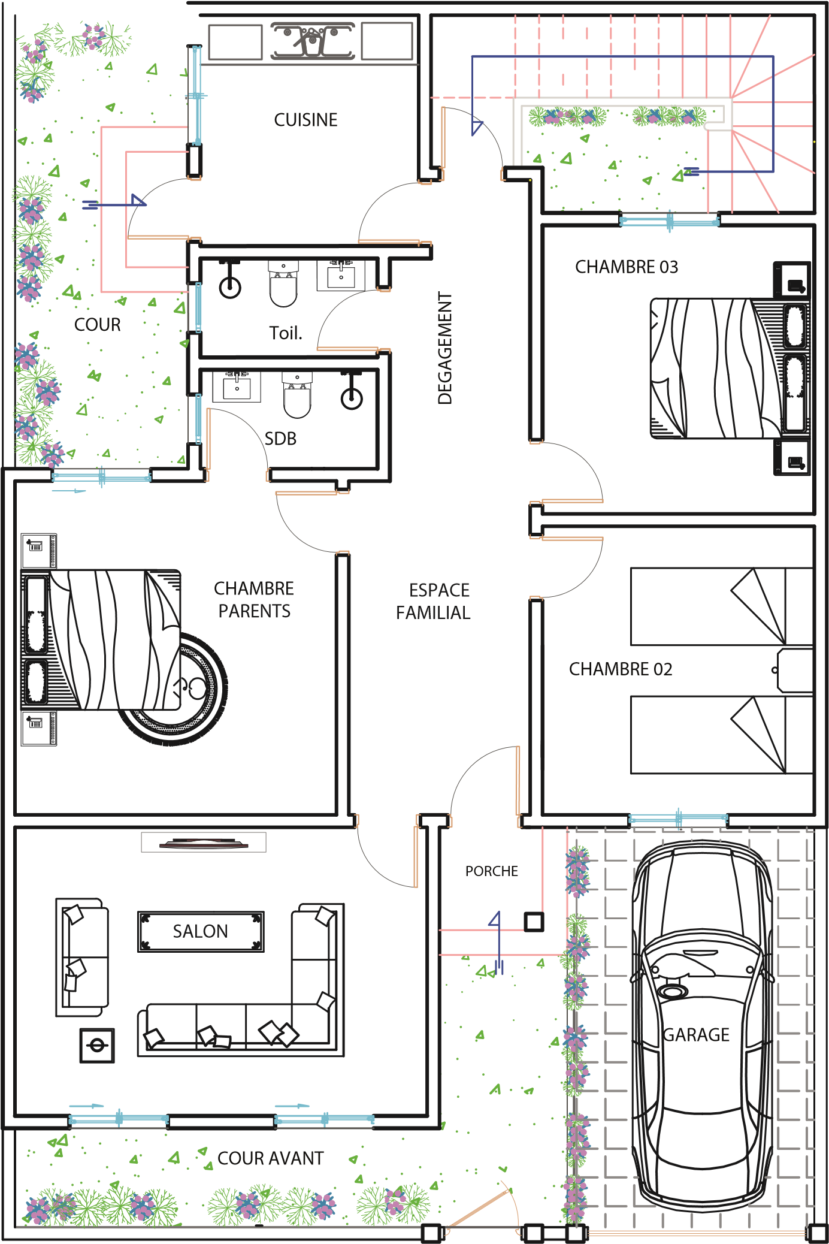

|  |  |  |  |  |  |  |  |  |  |  |  |  |  |  |  |  |  |  |  |  |  |  |  |  |  |  |
| --- | --- | --- | --- | --- | --- | --- | --- | --- | --- | --- | --- | --- | --- | --- | --- | --- | --- | --- | --- | --- | --- | --- | --- | --- | --- | --- |
|  | |  |  |  |  |  |  |  |  |  |  |  |  |  |  |  |  |  |  |  |  |  |  |  |  |  | | --- | --- | --- | --- | --- | --- | --- | --- | --- | --- | --- | --- | --- | --- | --- | --- | --- | --- | --- | --- | --- | --- | --- | --- | --- | | |  |  | | --- | --- | | REZ - DE - CHAUSSEE | | | SURFACE | m² | | Séjour | 30.45 | | Chambre 01 | 10.50 | | Dégagement | 04.00 | | Cuisine | 07.90 | | Escaliers | 06.45 | | Toilette | 03.00 | | Porche | 02.55 | | Terrasse 01 | 06.20 | | Terrasse 02 | 03.40 | | **Surface Habitable** | **74.45 m²** | | |

VILLA FATIMA F5 - RDC + 01 ETAGE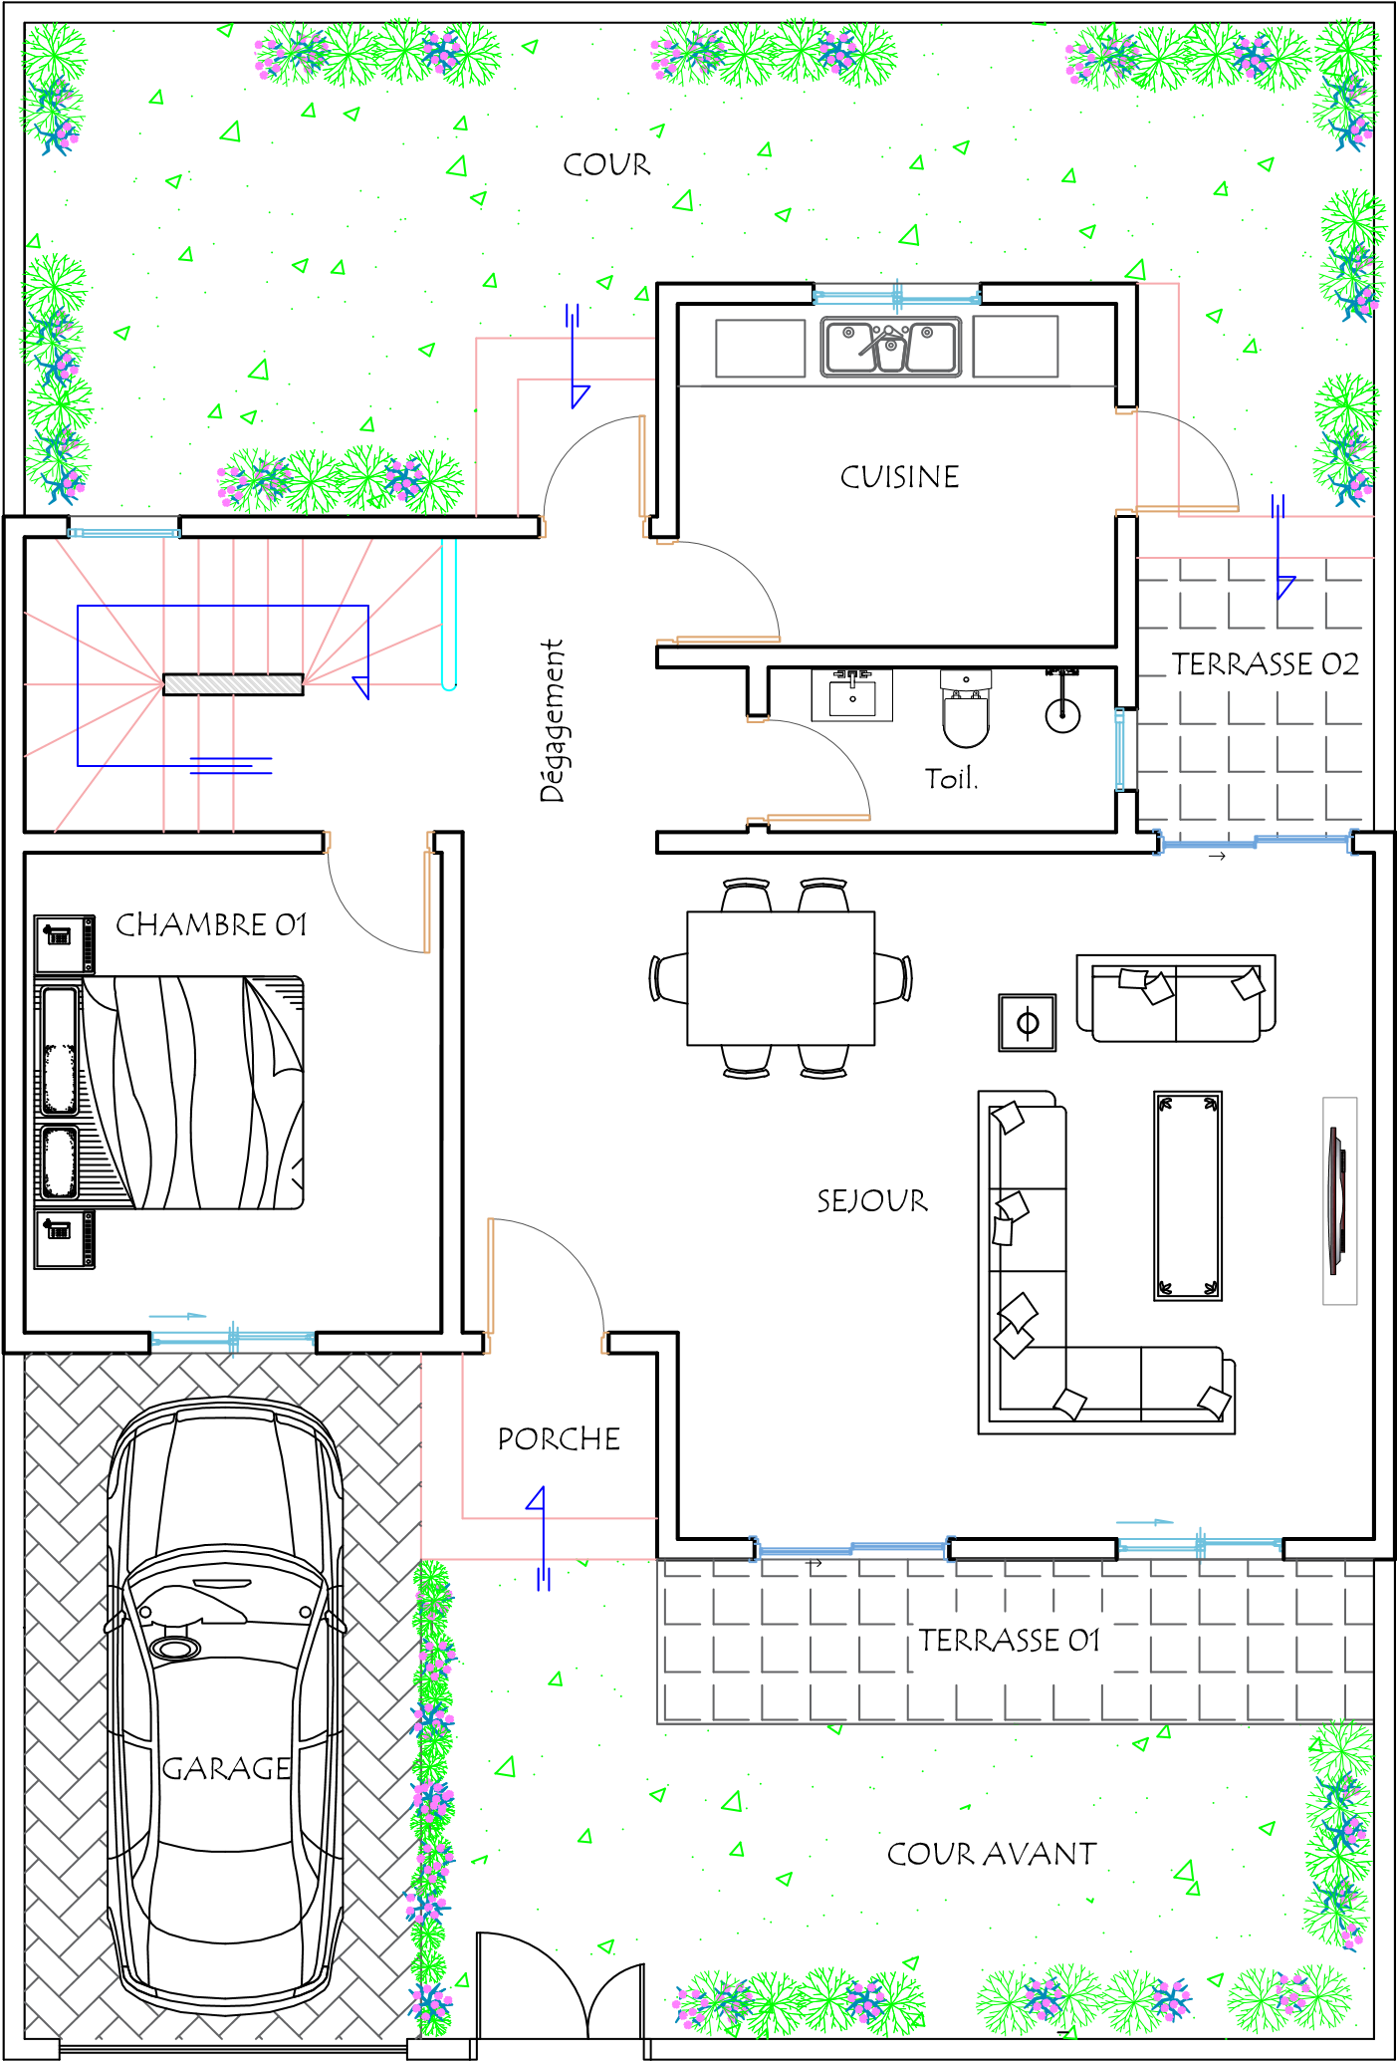

|  |  |  |  |  |  |  |  |  |  |  |  |  |  |  |  |  |  |  |  |  |  |  |  |  |  |  |  |  |  |  |
| --- | --- | --- | --- | --- | --- | --- | --- | --- | --- | --- | --- | --- | --- | --- | --- | --- | --- | --- | --- | --- | --- | --- | --- | --- | --- | --- | --- | --- | --- | --- |
|  | |  |  |  |  |  |  |  |  |  |  |  |  |  |  |  |  |  |  |  |  |  |  |  |  |  |  |  |  |  | | --- | --- | --- | --- | --- | --- | --- | --- | --- | --- | --- | --- | --- | --- | --- | --- | --- | --- | --- | --- | --- | --- | --- | --- | --- | --- | --- | --- | --- | | |  |  | | --- | --- | | ETAGE | | | SURFACE | m² | | Chambre 02 | 15.75 | | Chambre 03 | 12.15 | | Chambre 04 | 10.50 | | Salle de bain 02 | 04.15 | | Salle de bain 03 | 03.70 | | Salle de bain 04 | 03.00 | | Dressing | 04.15 | | Balcon 01 | 06.20 | | Balcon 02 | 02.10 | | Dégagement | 04.90 | | Escaliers | 06.45 | | **Surface Habitable** | **73.05 m²** | | |

|  |
| --- |
| Prix hors frais Notaire : 49 500 000 FCFA |

VILLA FATIMA F5 - RDC + 01 ETAGE 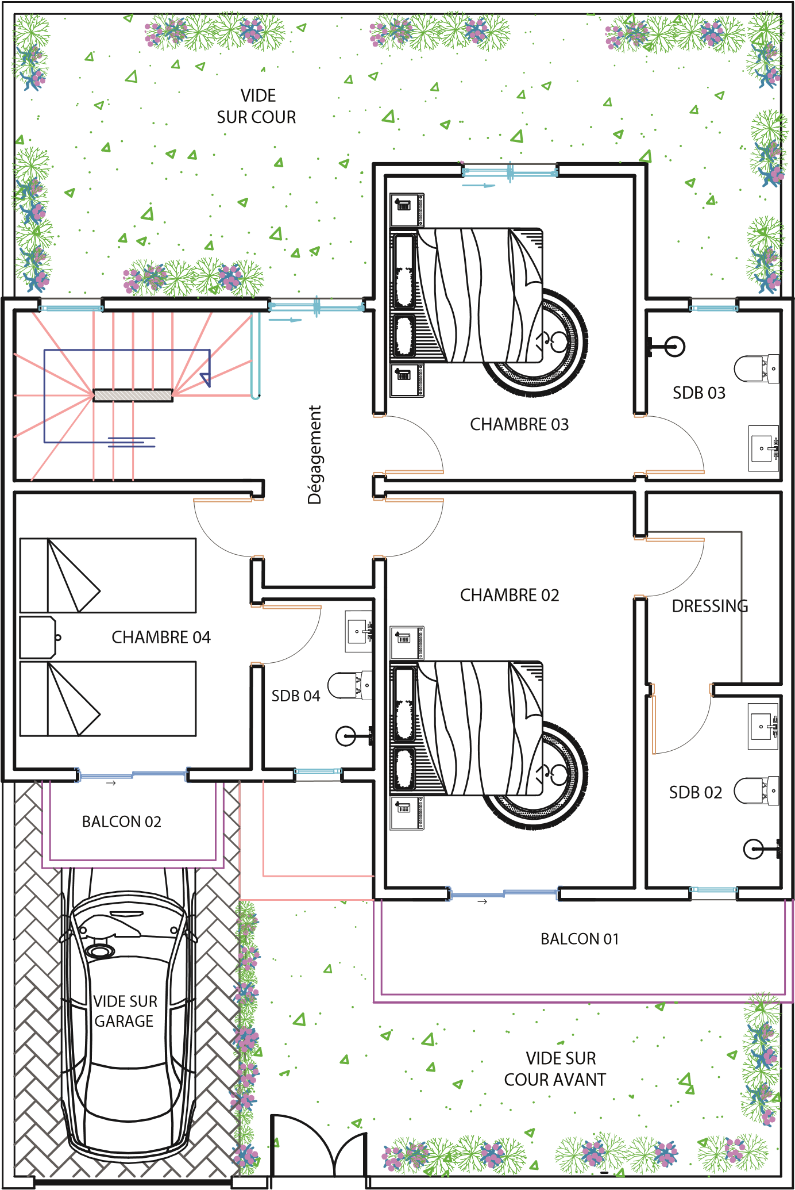



**Adresse :** Sacré Coeur 1 Immeuble D TRANSVEES 5 et 6

**Email :** scindongoimmo@gmail.com

Mame Fatou NDAO tél. : 77 658 42 65 (Commercial compt a créer avec le mail [mame@gmail.com](mailto:mame@gmail.com) passwor Mamafatou123)

Fatima NDONGO tél. : 77 126 28 40 Salimata CISSE tél. : 77 787 09 05

**NOTAIRE DU PROJET :**

**ETUDES MAITRE ABDEL KADER NIANG**

**Tél. :** 33 951 07 58